# CS3320 Image Compression Project rev 04

## I. Purpose

The purpose of this project is for you to learn the knowledge and skills needed to compress and reconstruct color photographs. Image and data compression are important activities for several of the major employers in Utah County (and elsewhere).

The current rapid movement of information over the web is made possible, in part, by data compression. There are multiple formats for video, sound and photographic file compression based on variants of the same discrete cosine transform that you learned this week and will apply in this project.

This project will also provide practical application of the data compression topic you studied in your Networks II class.

## II. The project has several steps;

1. Request your photographs-- Each student will be given two photographs to process. To obtain your photographs, send an email request to [CKnadler@uvu.edu](mailto:CKnadler@uvu.edu) and they will be sent to you in a reply to your request. (Do not use Canvas, you will not receive your photographs, because it does not strips attachments. Off.)
2. Study Section 11.2 of the text.
3. Thoroughly understand Computer Problem 11.2.3
4. Define your criteria for a “good” photograph and for a “usable” photograph. Your criteria are your own. You will not be graded on what your criteria are, but on your specifying and using them.
5. Write and debug your MATLAB script to compress and reconstruct your photographs. Be sure to use the approach demonstrated in the Compression slides, text section 11.2 and in Computer Problem 11.2.3
   1. The linear quantization matrix Q = p*8./hilb(8); (MATLAB code)
   2. The DCT C matrix is defined on the top of page 528
   3. The compression and decompression code on the top of page 533
6. Experiment with the loss parameter, P, (section 11.2.3) find the largest P-value giving a “good” photograph and the largest P-value giving an “usable” photograph for each of your two photographs.
7. Write and submit your report and MATLAB files.
8. (optional extra credit) Translate the transformed, quantized image components (a) 11.22 and (b) to bit streams using JPEG Huffman coding (ref. text Section 11.3.2, Additional Example 11.3 #2). Doing Section 11.3 Exercise 4 may be helpful for you. The answers to it are

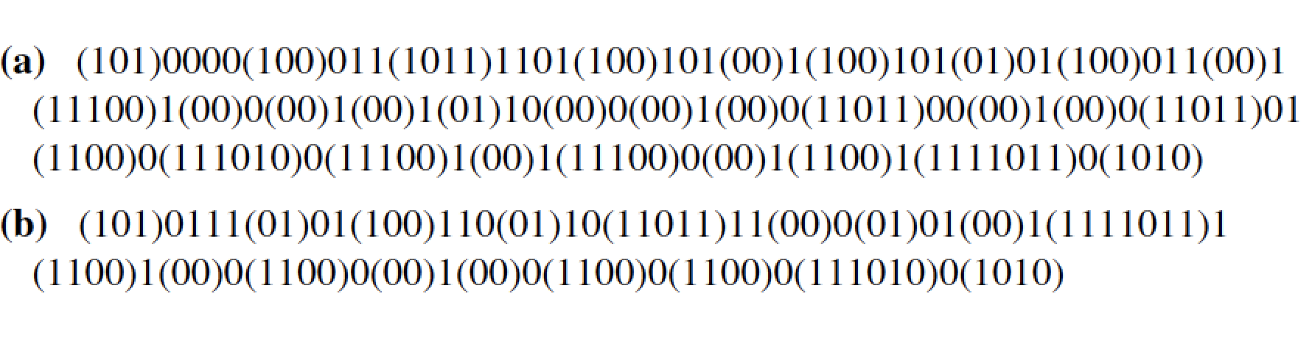

## III. Criteria

1. Submission Requirements 10% of the grade

You should submit 3 appropriately named pdf files:

1. The report see the requirements below.
2. A complete record for the first photograph—
   * Your MATLAB script
   * All MATLAB console output including images.
3. A complete record for the second photograph—
   * Your MATLAB script
   * All MATLAB console output including images.

2. Report Requirements 40% of the grade

Your report should include the following sections:

1. Introduction: includes your definitions of what is a ***good*** photograph and what is an ***usable*** photograph.
2. Discussion of the impact of *p* on your photographs. How did changing p affect the quality of your photographs; what is the largest value of p that gave a “good” -- largest value of p that gave a “usable” for each of your two photographs
3. Results: including the original photograph, the “good” photograph, and the “usable” photograph for each of your two photographs.
4. There should be no need to have more than 2 pages, not counting the six photographs.

3. Photographs -- 25% each photograph

a. The good, usable images and the original photograph were included in

the report and meet your criteria.

b. The project was done as specified using the specified algorithms. No

other compression algorithms, code, MATLAB toolboxes, etc. were

used.

4. Extra Credit – 10%

## HINTS:

1. Complete the required project first, then attempt to earn the extra credit.

2. Some students may have difficulty writing and debugging the code that breaks the photograph up into 8 x 8 blocks, processes them, and then reconstructs a full-size image. PLEASE, PLEASE do not procrastinate.

1. If you jump on the project, you can finish it in one or two days. Delay and experience says, it will surely take you much longer.
2. Suggestion: write and debug the code that creates and reconstitutes the 8 x 8 blocks into a full image first.